Jira link: <https://patronusbazaar.atlassian.net/jira/software/projects/PATRONUS/boards/2/backlog?selectedIssue=PATRONUS-4>

Git link: <https://github.com/Brahian117/PatronusBazar>

Validation logic during registration:

Successful registration:

Updated login with update menu view:

Validation error message:

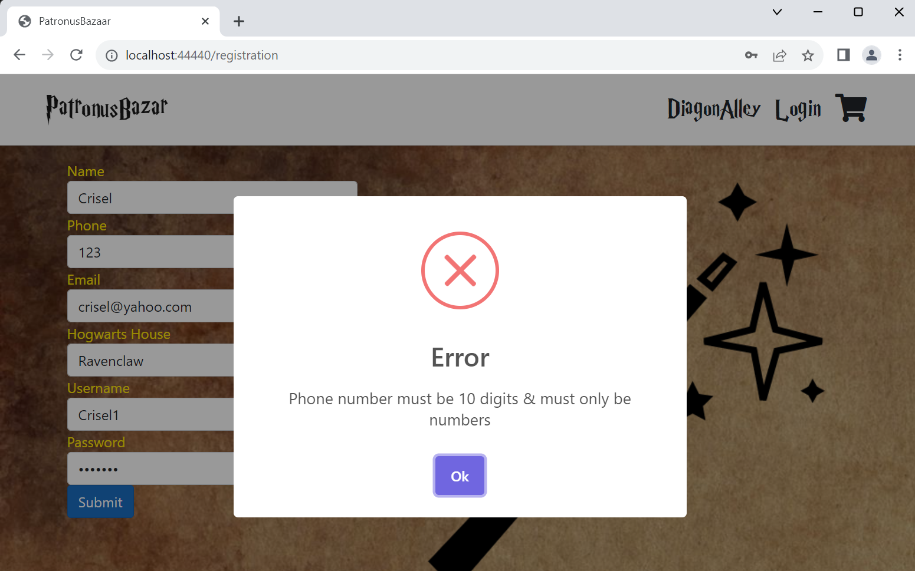

Jira updates:

Login task done

Registration task done:

Registration – validation: done

